Image | 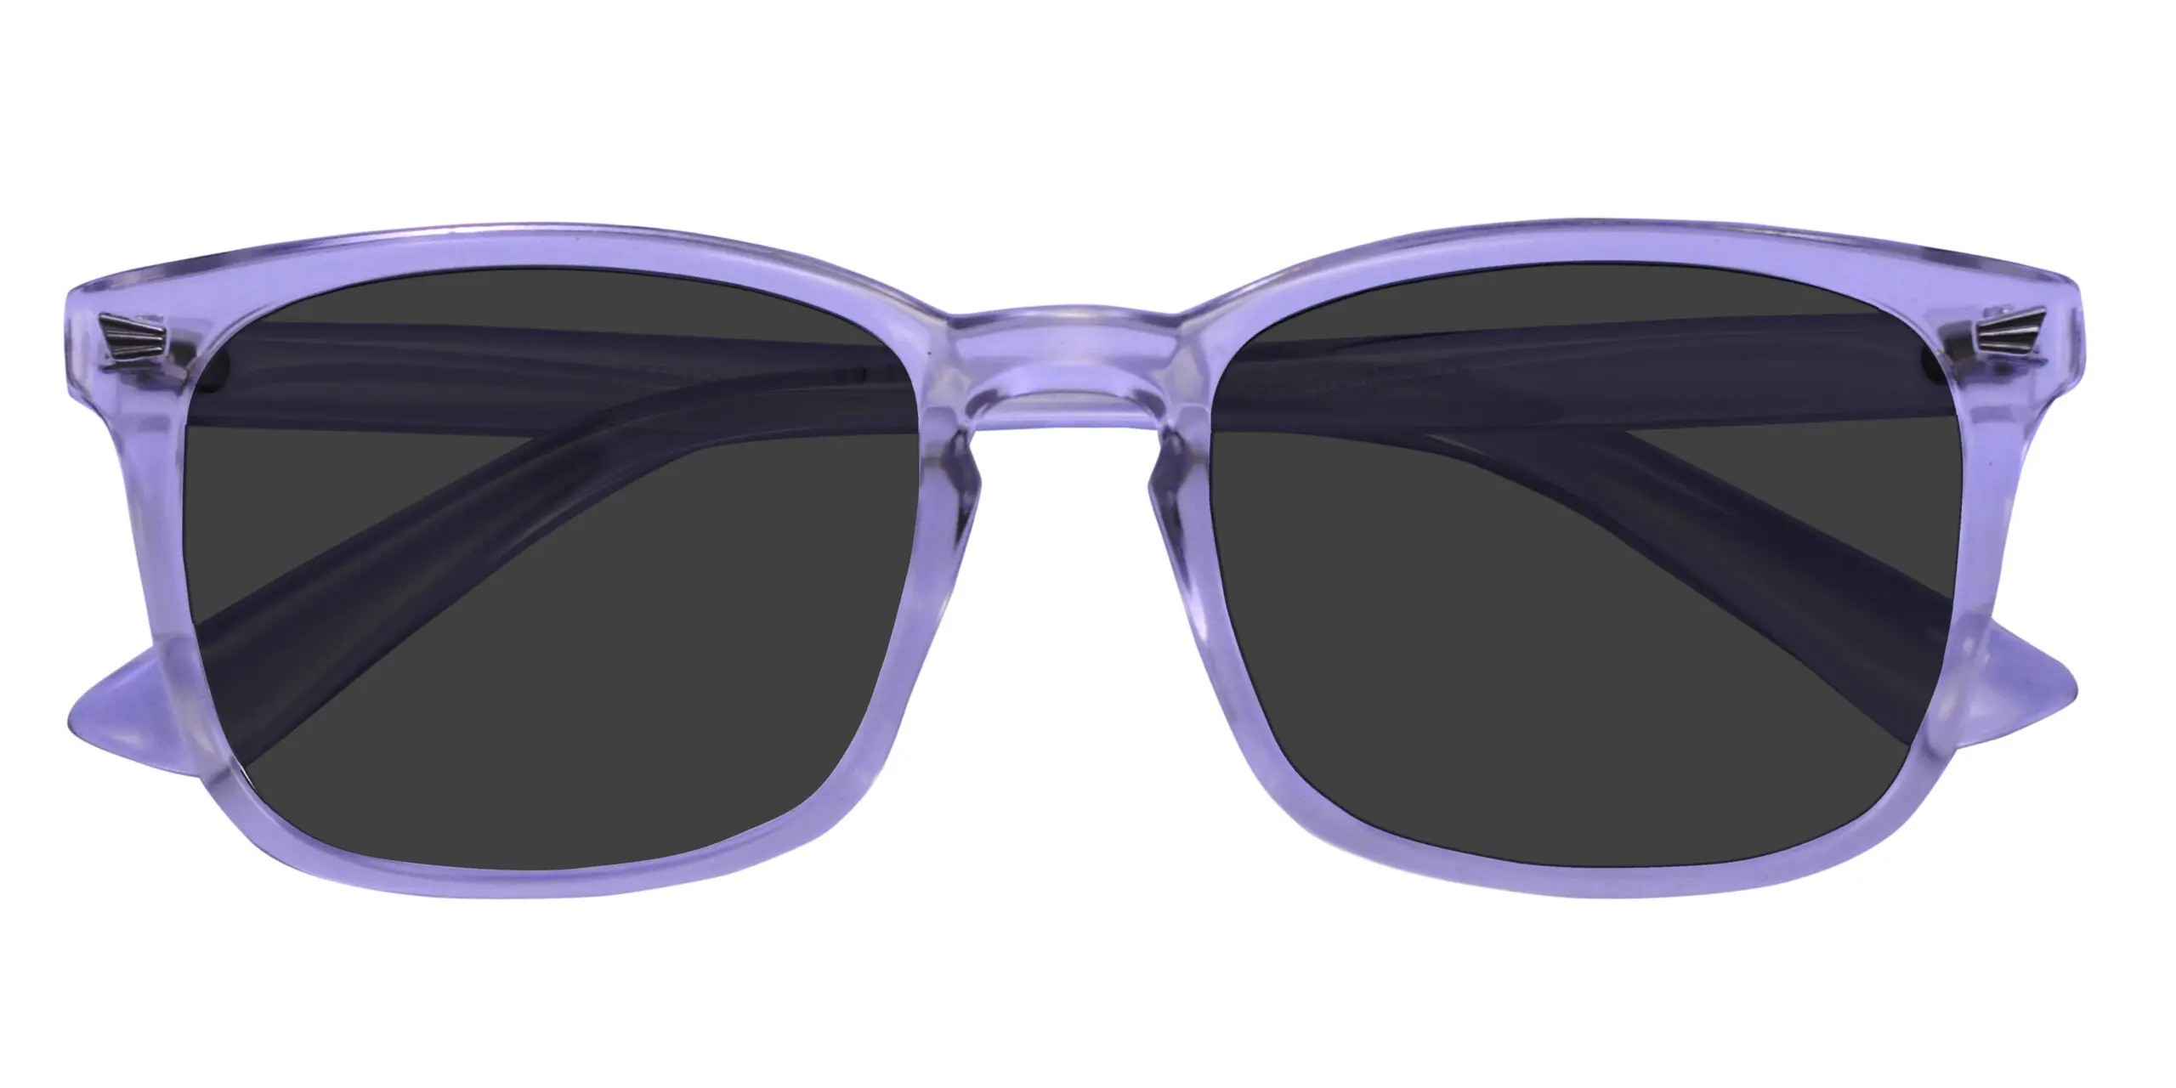
Brand | PRADA
Model Name | Coral P-1066
Price | RS 1200
PRODUCT DETAILS

